Attendance- Every Day Counts Punctuality- Every Minute Counts
‘90%’ attendance or ‘5 minutes late’ may sound like small issues but the amount of learning missed is huge.
Make each day count!

‘90%’ attendance or ‘5 minutes late’ may sound like small issues but the amount of learning missed is huge.
Make each day count!

‘90%’ attendance or ‘5 minutes late’ may sound like small issues but the amount of learning missed is huge.
Make each day count!

‘90%’ attendance or ‘5 minutes late’ may sound like small issues but the amount of learning missed is huge.
Make each day count!

Attendance Procedures
*New government guidance for Parents/carers and schools.
*Active from August 2024.

Fines/Holiday:
Holidays are in no circumstances authorised by school.
Unauthorised absence due to holidays will result in a fine being issued from Coventry City Council.
The government have increased the fines:
From August 2024, the fine for school absences across the country will be £80 if paid within 21 days, or £160 if paid within 28 days.
This government website provides more information: https://educationhub.blog.gov.uk/2024/02/29/fines-for-parents-for-taking-children-out-of-school-what-you-need-to-know/

Persistent Absence (PA)/ Risk of PA:
We want to avoid children becoming persistently absent (below 90%).
Interventions will be put in place when your child’s attendance becomes ‘at risk’ of becoming PA. This may include supportive child and parent meetings.
Being persistently absent may make you liable for fines or school attendance referrals.

.
Punctuality:
If your child arrives to school after registration closes, your child will receive an unauthorised late mark- this affects your child’s attendance.
Parents must accompany their child to sign in at the main office when they arrive late and provide a reason.

Medical Evidence:
We request that medical appointments (e.g. optician/dental) are booked outside of school hours. We do however accept that some appointments such as hospital/ specialist appointments need to be attended when they are made for your child. With all medical appointments, you must provide written/ electronic proof in advance to the school main office. This is to ensure that the absence is authorised.

Medical Evidence:
We request that medical appointments (e.g. optician/dental) are booked outside of school hours. We do however accept that some appointments such as hospital/ specialist appointments need to be attended when they are made for your child. With all medical appointments, you must provide written/ electronic proof in advance to the school main office. This is to ensure that the absence is authorised.

Medical Evidence:
We request that medical appointments (e.g. optician/dental) are booked outside of school hours. We do however accept that some appointments such as hospital/ specialist appointments need to be attended when they are made for your child. With all medical appointments, you must provide written/ electronic proof in advance to the school main office. This is to ensure that the absence is authorised.

Absence:
If your child is absent from school- you must contact the school via ‘My Child at School’ account or Telephone (02476687688) before 9:15am to provide a reason for absence.

Absence:
If your child is absent from school- you must contact the school via ‘My Child at School’ account or Telephone (02476687688) before 9:15am to provide a reason for absence.

Always on time | 0 hours missed | No learning missed
5 minutes late each day | 15 hours missed | 3 days learning missed
10 minutes late each day | 32 hours missed | 6.5 days learning missed
20 minutes late each day | 65 hour missed | 13 days learning missed
30 minutes late each day | 95 hours missed | 19 days learning missed

100% | 0 days missed | No learning missed
97% | 5 days missed | A weeks learning missed
94% | 12 days missed | 2 weeks and 2 days learning missed
90% | 19 days missed | 3 weeks and 4 days learning missed
85% | 30 days missed | 6 weeks learning missed
80% | 40 days missed | 8 weeks learning missed

Our Mission
At Longford Park Primary School we all believe that good attendance is vital for a child to achieve and their full potential.
We promote good attendance by providing a safe and motivating environment for all children.
As a team, we will together break down any barriers a child or family may have to accessing their education.
Every child matters, every minute matters and every day of learning matters.

Parental Home/ School Agreement
Parents/Carers AND school both have a legal duty for attendance.
It is a legal requirement for each and every child to access regular education.
School will provide regular information to parents/ carers regarding your child’s attendance.
I need support with my child’s attendance
If you need support with your child’s attendance, please reach out to a member of staff and they will pass on your enquiries/ questions/ concerns to the right person. We are all here to help you.

Frequently Asked Questions

What is PA?
PA stands for ‘Persistently Absent’. This is when your child’s attendance is below 90%.

What is risk of PA?
‘Risk of PA’ is when your child’s attendance is at risk of dropping below 90% - we aim to offer early intervention support at this stage.

What is EPN?
EPN stands for ‘Education Penalty Notices’. EPN’s are issued for unauthorised absences, this includes term time holidays.

What happens if I simply say, ‘I’ll just go on holiday and pay the fine’?
EPN’s have now been capped nationally at two fines within a three year period. After this, other action like a parenting order or prosecution has to be considered- this could mean a fine up to £2500.

What is an unauthorised absence?
A child being kept off school unnecessarily or without reason. Term time holidays is not a justified reason to take your child out of school.

What happens if I keep my child off and do not contact the school?
School will make a first day call to try to gain a reason for the absence- if no reason is provided, school may carry out a visit to your home- this is to check on the welfare of you and your child.

Longford Park
Primary School
Attendance Guide for Parents/Carers

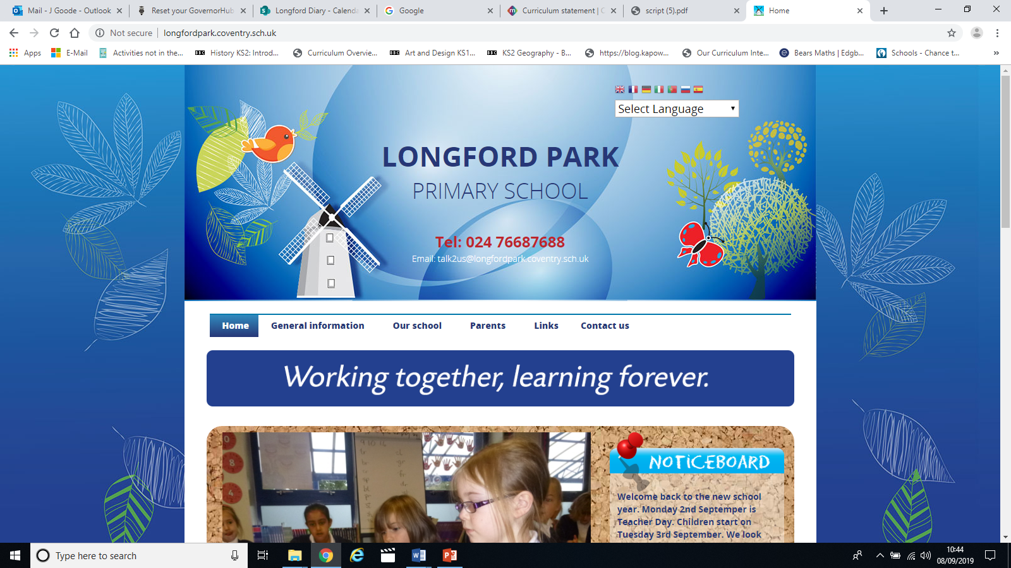

‘Working together, Learning forever’

All enquiries regarding attendance should be brought to the attention of Mrs Goode (Headteacher / DSL and Senior Attendance Officer) or Mrs Virk (School and Attendance Admin).

Tel: 02476687688
Email: Admin@longfordpark.coventry.sch.uk / Headteacher@longfordpark.coventry.sch.uk
Website: http://www.longfordpark.coventry.sch.uk/

*Please also refer to the full attendance policy that can be found on our school website

