Longford Park Primary School


LONGFORD PARK PRIMARY SCHOOL
‘Working together, Learning forever’

Positive Behaviour Policy

Written by | J. Goode
Reviewed by | J. Goode and Longford Park Staff
Review Date | Reviewed March 2026 as amended strategies
Signed Chair of Governors
Review Date | September 2026

Introduction:
Behaviour at Longford Park Primary School is a collective responsibility with the children at its heart. We all know that behaviour is a form of communication so at Longford Park, all adults will build strong, positive and respectful relationships with the children. This revised policy aligns with Keeping Children Safe in Education (KCSiE) 2025 and the updated Anti-Bullying Policy to ensure consistency in safeguarding, behaviour expectations, and restorative practice.

Longford Park Primary School is committed to creating an environment where exemplary behaviour is at the heart of productive learning. Everyone is expected to maintain the highest standards of personal conduct, to accept responsibility for their behaviour and encourage others to do the same. Our positive behaviour policy guides staff to teach self-discipline, restorative practice and not blind compliance. It echoes our core values with a heavy emphasis on respectful behaviour, a partnership approach to managing poor conduct and dynamic interventions that support staff and learners can follow. Consistency, and clear, calm adult behaviour underpins this.
'If you consistently reward minimum standards then children will strive for minimum standards. If you reward children for ‘going over and above’ then there is no limit to their excellent behaviour.' -Paul Dix
At Longford Park Primary School, we practise ‘over and above’ behaviour at all times, so that all members of our community can follow the three rights:
- The right to feel and be safe
- The right to learn
- The right to be treated with respect
Aims:
- To provide a clear, fair and consistent approach to behaviour based on nurturing principles and restorative practices.
- To foster, nurture and value strong and healthy relationships in recognition of the importance of this as a lifelong skill.
- To provide a safe, respectful, equitable and happy school ethos where learning opportunities are maximised.
- To give staff the tools to enable them to support and equip children with strategies to manage their behaviour and build positive relationships with others.
- To create a culture of exceptionally good behaviour: for learning, for community, for life.
- To ensure that all learners are treated fairly, shown respect and to promote good relationships.
- To refuse to give learners attention and importance for poor conduct
- To help learners take control over their behaviour and be responsible for the consequences of it. • To ensure that excellent behaviour is a minimum expectation for all

Our Values
At Longford Park Primary School, our aim is to be proactive rather than reactive- to foster a positive environment where children exhibit a sense of commitment and pride in the school, promote excellent home/school partnerships with parents thereby encouraging effective two-way partnerships and genuinely celebrate the success of others. We aim to help children develop the following core strengths through our STARS values.

S | Self-Esteem- Appreciating our worth in ourselves and others
T | Trust- Being honest and open about how we feel.
A | Aspiration- Belief in oneself and others to be the best version of themselves
R | Respect- Respecting each other’s differences. Growing, forming and keeping healthy relationships
S | Support- Helping one another, ensuring that everyone is included and no one is left out/ struggling

The STARS Values are known and respected by the school community and are displayed in each classroom and throughout the school. Examples of how to demonstrate the values are learned about in assemblies and throughout the PSHE programme and are revisited with the children at every opportunity.
Thrive
Longford Park Primary School is a THRIVE accredited school; supporting children’s emotional and social well-being. We complement our Positive Behaviour Policy with a restorative approach to teaching our children about their emotions and learning from our actions. Restorative approaches enable those who have been harmed to convey the impact of the harm to those responsible, and for those responsible to acknowledge this impact and take steps to put it right.
'Punishment doesn't teach better behaviour, restorative conversations do.' - Paul Dix

Expectations and Roles
Expectations and role of ALL adults:
- Meet and greet every child every morning.
- Refer to 'STARS’ and reward those who are showing one of our school values.
- Model green choices and build strong, positive and respectful relationships.
- Be calm and give 'take up time' when going through the steps. Prevent before sanctions.
- Plan lessons that engage, challenge and meet the needs of all learners.
- Follow up behaviour every time, retain ownership and engage in reflective dialogue with learners.
- Encourage use of 'relentless routines' (e.g. walking in the corridors, single file walking in a line)
8. Never ignore or walk past learners who are behaving badly.

Expectations and role of the Senior Leaders and SENDCO:
It is the responsibility of the senior leaders and SENDCO to implement the school behaviour policy consistently throughout the school. Senior leaders set high expectations through consistently modelling the STARS values and strive to ensure that all children work to the best of their ability. It is also the responsibility of the senior leaders to ensure the health, safety and welfare of all children in the school.
- Take time to welcome children and family members at the start of the day
- Be a visible presence around the site and especially at transition times
- Celebrate staff, leaders and learners whose effort goes above and beyond expectations
- Regularly share good practice
- Support adults in school in managing learners with more complex or entrenched negative behaviours
- Regularly review provision for learners who fall beyond the range of written policies

Expectations of Parents and Carers:
Parents have a vital role to play in their child’s education. It is very important that parents support their child’s learning and co-operate with the school. We are very conscious of having strong links with parents and good communication between home and school. Parents will engage with Class Dojo to support children’s green choices and positive behaviours in school.
Parents can address any queries regarding sanctions, firstly to the class teacher, then to the Deputy or Headteacher.

Expectations of the Pupils:
What does good behaviour look like?
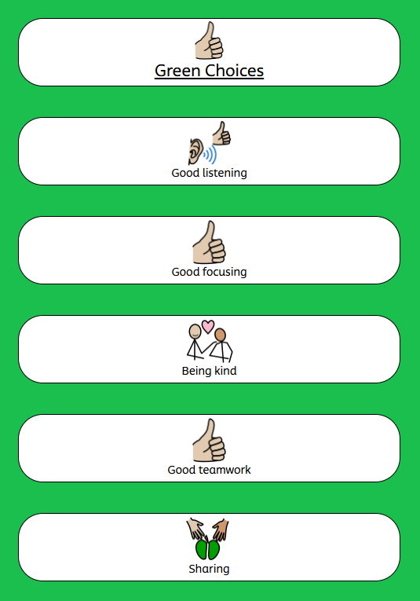
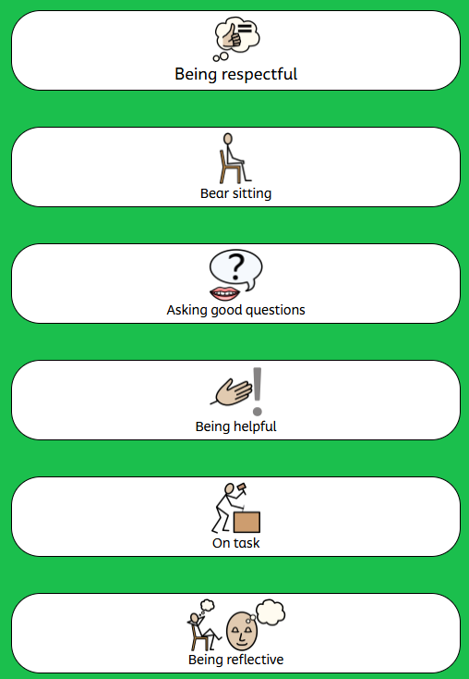
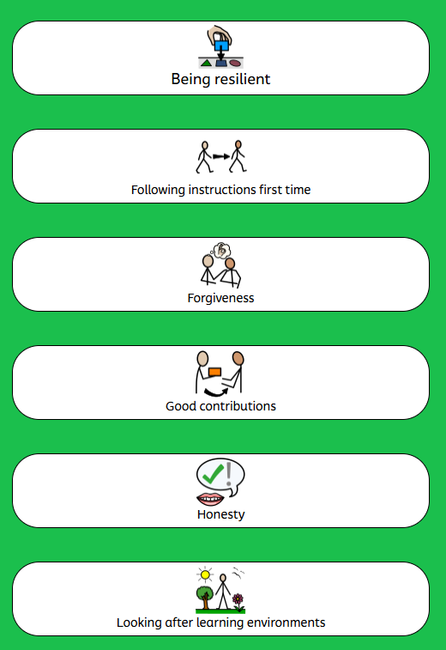
At Longford Park, we use green choices to represent good behaviour. These cover all aspects of school life – in the classroom, walking around school, on the playground, in assembly and when we have visitors in and take the children out on visits to enrich their learning.
**SEND & Behaviour
At Longford Park Primary School, SEND is not considered an excuse for poor behaviour, however for children whom a staged approach is not appropriate, due to their particular Special Educational Needs or Disability, will have a personalised plan or behaviour plan detailing alternative approaches, rewards and techniques.

We recognise that inclusion does not mean that all children are treated in the same way; we support individual needs in consultation with the Parents / Carers, Class Teacher, Thrive and Well-being champions, SENDCO and SLT.

The introduction of the red and green choices is a way in which we are universally supporting children to understand their behaviour choices however they are also an Autism-friendly approach to supporting children with SEND, particularly those with Autism, about desired and undesired behaviours.

Where children are struggling to make the right behavioural choices or where a Special Educational needs or disability has been identified, support may be offered from external agencies.

Positive Strategies

Adults in school will create a welcoming environment by greeting pupils every morning through a formal ‘meet and greet’ either at the classroom door or at each child's classroom seat. This will be a simple, 'Good morning' to provide a consistent check in and enthusiastic welcome to every child. All adults at Longford Park School will use positive strategies consistently. They are designed to ensure attention goes to those children going ‘over and above’ and to create clear, simple routines and expectations that make children feel valued members of our learning community and motivated to always try their best.
'The foundation of every school must be excellent behaviour. We should be keeping the focus on a
visible culture of impeccable conduct, and making the consistency palpable, audible and highly visible.' -Paul Dix

All adults will be looking out for children who show Longford Park Values and ‘go over and above’ and showcase consistent and continuous green behaviours.

Ways that children will be recognised for doing so:
- Adults congratulate children through non-verbal, written and verbal feedback.
- Class dojo points are awarded. These are then transferred into house points. These Class Dojo points are communicated to parents via the Class Dojo app.
- Positive notes/ Phone calls home/ Speaking to adults at drop off and pick up times are a high level of recognition for children who are consistently going ‘over and above’. Any adult in school can make contact with parents/carers to give positive feedback. There is no set amount each week - again it must be sincere to keep its value.

'A positive message home enables you to mark the moment with the child. You are framing them with their best behaviour, their most determined effort, their greatest show of resilience.' -Paul Dix

- Adults in school give children a variety of agreed in-class rewards e.g. stickers
- Staff award House Points. This could be directly or indirectly through Class Dojo. Points are reviewed weekly, logged, and celebrated. The winning house (house with most points) at the end of each half term will earn a reward (e.g. an out of uniform day, extra break time). Points are reset at the start of each half term.
- Headteachers Award – On alternate weeks, EYFS & KS1 / KS2 are chosen to receive a Headteacher Award for demonstrating consistently high behaviour choices or our school values.
- Peer nominations – Children can nominate each other to receive an award in celebration assembly for green choices and showing a value.
- Teacher’s and Teaching Assistants will recognise good learning and will encourage children to share their learning with the Headteacher and Deputy Headteacher. Stickers/ certificates will be awarded for this.

Consequences of inappropriate behaviour and red choices

At Longford Park Primary School, we recognise that there are, on occasion, times that mistakes / red behaviour choices can and will be made.
The children are learning their way in the world and will need help and guidance at times. At Longford Park School, our aim is to be proactive in supporting children to learn from mistakes / red choices and take ownership of their own actions. This may mean accepting a consequence for these actions.

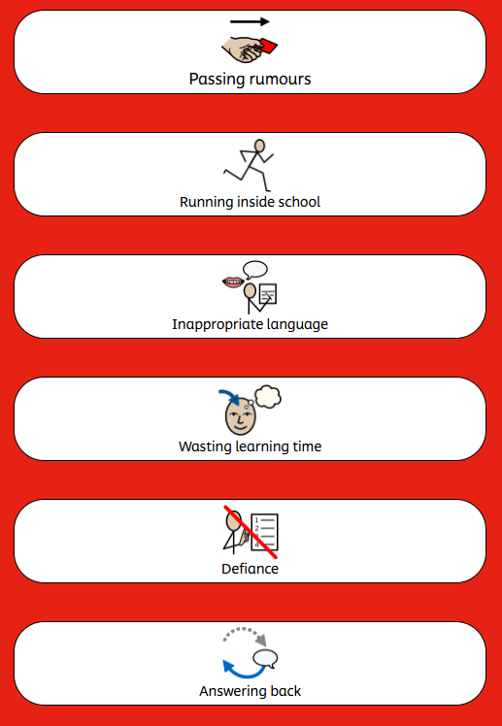
We utilise red choices to support children to identify behaviour that is undesired within school.
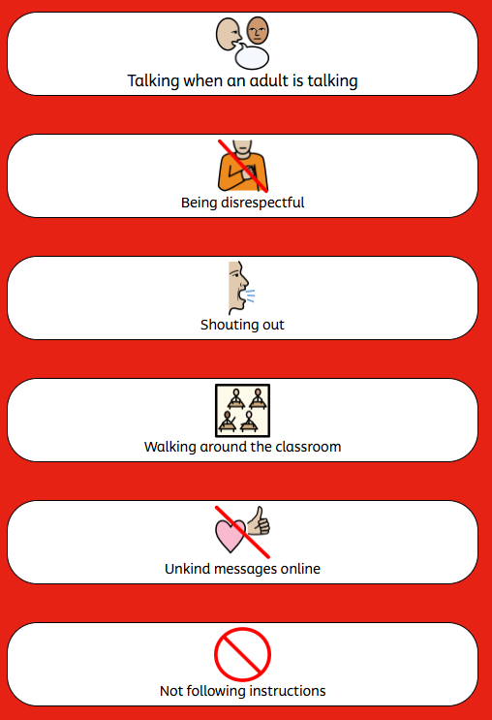
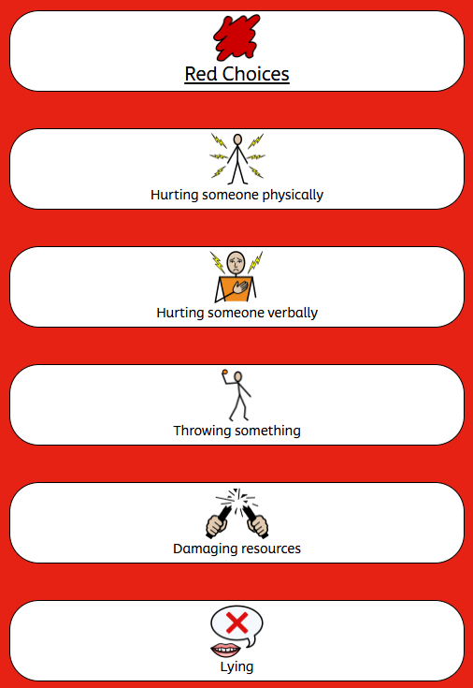

At Longford Park School, we use a restorative approach to resolving and repairing conflict and tackling red choices. We do not welcome punishments that set out to humiliate or belittle a child. Our aim is to treat each child with respect and dignity. All consequences have a learning outcome and aim to teach children that there are always repercussions for red choices and inappropriate behaviour. Our goal is to help the children learn to make informed green choices and positive decisions and to identify a better way.

We use a staged approach for every child, which has been developed to ensure that children can access it regardless of their individual needs. Where required, a reflection booklet is used to support and guide the reflection conversation. This gives options for children to select from when being asked a series of reflective and restorative questions. Our stages are:

- Verbal warnings are clear and specify the behaviour that is disrupting learning. Children will be directed to the Red and Green Choices and asked, “Have you made a red or green choice?” This will allow the child to recognise that their choice of behaviour needs amending. *see appendix 4.

- A Yellow Reflection: If the behaviour continues, the child will complete a yellow reflection at the reflection table in their classroom/ or just outside of their classroom for 10 minutes (see appendix 3).

- An Amber Reflection: If the child has returned to their learning and the behaviour continues, a time out in the year group above or below is given. They will complete an amber reflection and return to class after 10 minutes (see appendix 4).

- A Red Reflection: If after each of the previous steps has been completed and the child’s behaviour continues to be unacceptable, they will be asked to complete a red reflection. A red reflection will mean that the child will need to be brought to the SLT office. The children must bring their yellow and amber reflections so these can be discussed with the child (see appendix 5). For instances of child-on-child abuse, children will complete a red reflection with a member of SLT immediately.

We use a system of reflections so all children can communicate their views on an incident and use this time to calm down after an incident. If a child is unable to write their reflection, they may be asked to draw or given a scribe.

Below are examples of pages from the reflection book that is used to help all children to express what has happened, why it has happened, how it made themselves and others feel and how to repair and restore the relationship. This is available in every classroom to support children’s access to that holistic, meaningful reflection conversation.

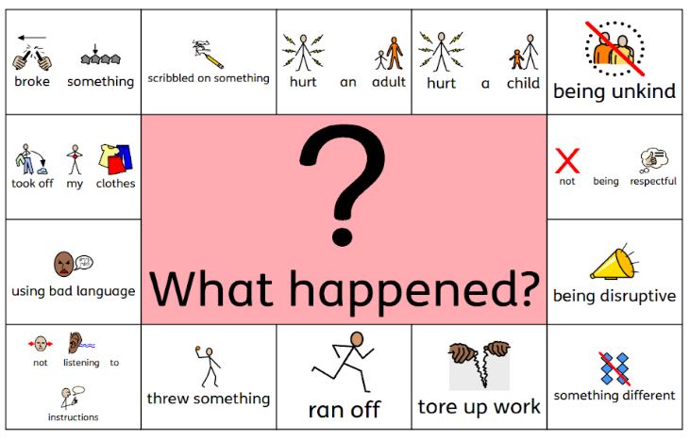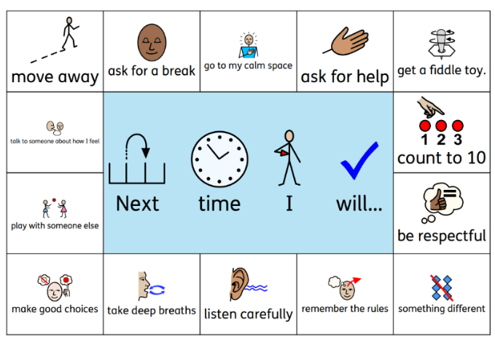

The Headteacher has the responsibility for giving fixed-term suspensions to individual children for serious acts of misbehaviour. For serious offences or repeated misdemeanours, as outlined in Table A, pupils may be suspended from classes for a fixed period of time within the school setting (internal suspension) or for a fixed term suspension from school for a period of time (external suspension). The Headteacher, or in their absence the Deputy Headteacher will have the full disciplinary power over pupils in the school and can temporarily exclude a pupil from the school if deemed necessary. Only the Headteacher, or a designated local authority representative, are the only individuals who can exclude a pupil permanently. A decision will only be made in a lawful, reasonable and fair manner. The Headteacher may decide to permanently exclude, if behaviours are deemed to be:
- The pupil has seriously or persistently breached the school’s behaviour policy.
- And/or if the pupil remaining in school would seriously harm the education or welfare of the pupil or others in the school
Behaviour expectations extend beyond the school gates. Incidents occurring off-site, including online behaviour, will be addressed in line with this policy and safeguarding procedures. Cyberbullying and harmful online conduct will be managed in collaboration with the Online Safety Policy and may involve external agencies where necessary.

*Actions will always be discussed with the school governors, and a decision will be made in the best interest of all individuals involved.

Policy Blueprint & Classroom Plan:

Behaviour Policy Blueprint (See Appendix 1):
This is a concise A4 document, that all adults will refer to, for a consistent approach to ensure behaviour and expectations are clear and consistent.

Classroom Plan (See Appendix 2):
The Classroom Plan is a sequence of steps, which are focused on small but certain consequences and a restorative, not punitive ending. The plan will be used by every adult to ensure consistent language and steps are being used throughout the school, and expectations and consequences for the children are clear.

Scripted Response (See Appendix 3):
As part of the Classroom Plan, a 30-Second Script will be used to reinforce expectations when behaviour shown is not reflective of our school values. This will take place at Step 3 of the Classroom Plan. The purpose of this script is to provide a quick, consistent and non-judgmental dialogue with the child to encourage positive choices to be made. The scripted response should be delivered in an emotionless tone, designed to prevent escalation. Once the script has been delivered, the child 'owes up to 5 minutes'. They then must stay behind at break time or lunch to have a quick discussion with the class teacher. The 5 minutes should be an opportunity to consider what the antecedent was to the poor behaviour choice, why the behaviour was unacceptable and what a preferred behaviour choice would be.

Personalised Relationship Plans/ Targets:
These plans/targets are in place for children with behaviour as an additional need. Relevant teachers/ Thrive and Well-Being Champion/ SENDCO will create these personalised plans for all adults working with the child to follow. They will be created with input from the child and shared with parents and school staff (including supply staff).

Restorative Meetings/Conversations:
Every adult in our school is important and has the ability to deal with poor behavioural choices. If an incident takes place on the playground/ school field (break/lunch) support staff (including lunchtime supervisors), will use the same strategies as teaching staff to respond to the behaviour. This allows an intervention to take place immediately and may involve a restorative conversation. It will not usually then be revisited by the class teacher or management team unless further action is required. Teachers and Teaching Assistants will deal with almost all behaviours, which take place during lessons. In order to minimise loss of teaching and learning time, senior leaders may become involved in a variety of ways e.g. releasing the class teacher to have a restorative meeting with a child.
*There may be occasions when the child/children are passed onto their Teacher/ Teaching
Assistants/ SENDCO and members of the senior Leadership team if the behaviour seriously or
persistently breaches the school’s behaviour policy. And/ or if the pupil remaining in school would seriously harm the education or welfare of the pupil or others in the school.

'The positive relationships you form with pupils depend on a restorative approach being your default mode.' -Paul Dix

At Longford Park Primary School, we believe that nurturing restorative practice, as well as high expectations, is imperative to building positive relationships. Restorative meetings and/or conversations aim to help the child realise how their behaviour affects others, teach what appropriate behaviour looks like and equip the child with tools they can use to avoid a similar incident occurring in the future.

Restorative Questions (See Appendix 4)
These restorative questions are a guide to supporting restorative meetings and/or conversations. For children in KS1 and KS2, up to five questions will be used. For children in the early years setting, the teacher may decide it would be more appropriate to start with two and build on these as the child develops in maturity.
Consequences:

'Children need people, not punishment. It is time we gave them what they need to succeed, not simply what we feel they deserve. Exclusion and heavy sanctions rarely meet the needs of the child.'-Paul Dix

If a child is not responding to the positive strategies, there needs to be clear, consistent consequences chosen by the adult dealing with a specific incident. For children with behaviour as an additional need, examples of these will be detailed on their personalised Relationship Plan.

Consequences implemented can be 1) 'Minutes owed', 2) 'Pay it back time' or, in more serious circumstances, 3) parental phone calls home, face-to-face meeting or a fixed term
suspension/permanent exclusion may be appropriate. They are designed to encourage the child to make 'good' choices and understand that their actions have consequences. For example, not completing work in class due to choices made regarding behaviour that is not reflective of our school values results in lost learning time, which then needs to be paid back.

- ‘Minutes owed'- a reflective time where the child and class teacher/ teaching assistant privately discuss their actions and how it has affected others. This will be at the start of playtime or lunchtime. The purpose of this is to enable the adult to remind the child of our school values and to encourage positive behaviour in future. The adult who engages with the child during the ‘minutes owed’ time period should be the adult who addressed the poor behaviour choice with the child.

- 'Pay it back time'- is an appropriate action linked to the incident and value, which has not been shown. For example, if a child has not completed class work due to failure to respond to positive strategies, the child uses ‘free time’ to catch up or in some circumstances, a copy of the work may be sent home for completion. Another example would be if there has been vandalism in the playground, we might ask the child or children involved to help repair the damage.
- Parental involvement- We feel it is important for parents to be aware of repeated and/or more serious incidents. We will communicate this through a phone call, or an informal or formal meeting.
Managing behaviour engagement with learning is always our primary aim at Longford Park Primary School. For the vast majority of our learners, a gentle reminder is all that is needed. Although there are some occasions when it is necessary for a child to leave their classroom for a short period, however steps should always be gone through with care and consideration, considering individual needs where necessary. Praise the behaviour you want to see. Do not pander to attention seekers.
All learners must be given 'take up time' in between steps. It is not possible to leap or accelerate steps for repeated low-level disruption.

Low-level behaviours can be defined as: | Behaviours that may warrant immediate escalation can be defined as:
- Talking in the classroom when the child should be listening to adults or peers  - Lack of focus/off task  - Calling out unnecessarily  - Turning around and distracting others  - Persistent tapping and banging of equipment to distract others  - Wandering around the classroom unnecessarily  - Talking when lining up  - Running not walking around the school  building | - Refusal to do as asked  - Rudeness to peers or adults  - Leaving the classroom without seeking permission  - Disregard for school property- on purpose or as a result of poor behaviour choices  - Play fighting- pushing, grabbing, spitting, pinching  - Inappropriate language  - Any form of bullying  - Sexual assault, which is any unwanted sexual behaviour that causes  humiliation, pain, fear or intimidation  - Vandalism  - Theft  - Fighting  - Racist, sexist, homophobic or discriminatory behaviour and/or language  - Possession of any prohibited items.  - Actual harm towards another child or member of staff.

Table A

Practical steps in managing and modifying poor behaviour:

Learners are held responsible for their behaviour. Staff will deal with behaviour without delegating. Staff will use the 'Stepped Sanctions' for dealing with poor conduct. It is the aim that learners should be kept at steps 1 and 2 for as long as possible.

However, in some circumstances, some behaviours may warrant skipping a step and go straight to a ‘Minutes owed’ or a ’restorative conversation’. In more serious circumstances, a phone call home may be made or a face-to-face meeting.

Examples of low-level and more serious misbehaviours:
As referenced above, it is not possible to leap or accelerate steps for repeated low-level disruption and it is the aim that learners should be kept at steps 1 and 2 for as long as possible. However, some behaviours may need escalating to steps 3-5. Please find below a table that outlines some examples of low-level behaviours and behaviours that may warrant an immediate escalation to steps 3-5.

Longford Park Primary School operates a Zero Tolerance policy for racism, homophobia, bullying, childon-child abuse, sexual harassment, and physical assault. These behaviours will be referred immediately to SLT which includes the Headteacher and Deputy Headteacher. This fulfils the escalation of severity to the Headteacher who the DSL for the school. While sanctions are applied, the school prioritises restorative conversations to help children understand the impact of their actions and repair harm.

Child on Child Abuse

Children and young people may be harmful to one another in a number of ways, which would be classified as child on child abuse. Abuse is abuse and should never be tolerated or passed off as ‘banter’ or ‘part of growing up’ (KCSiE, 2025). All forms of child on child abuse are categorised as RED level behaviours and will be referred straight to the SLT. There are many forms of abuse that may occur between peers and this list is not exhaustive:

Intentional physical abuse

Physical abuse may include, hitting, kicking, shaking, biting, hair pulling, pushing or otherwise causing physical harm to another person. At Longford Park School, we recognise that there may be many reasons why a child harms another, and it is important to understand why a young person has engaged in such behaviour, including accidently before considering the action or punishment to be undertaken.

Sexually harmful behaviour/sexual abuse e.g. (inappropriate sexual language, touching, sexual assault etc.)

Sexually harmful behaviour may range from inappropriate sexual language, inappropriate role-play, to sexually touching another or sexual assault/abuse. Sexually harmful behaviour from young people is not always contrived or with the intent to harm others. There may be many reasons why a young person engages in sexually harmful behaviour, and it may be just as distressing to the young person who instigates it as well as the young person it is intended towards.

Bullying (physical, name-calling, homophobic etc.)

Bullying is unwanted, aggressive behaviour among school-aged children that involves a real or perceived power imbalance. The behaviour is repeated, or has the potential to be repeated, over time. Both young people who are bullied and who bully others may have serious, lasting problems.

Bullying includes actions such as making threats, spreading rumours, attacking someone physically or verbally or for a particular reason e.g. size, hair colour, gender, sexual orientation, and excluding someone from a group on purpose.
*See Anti-Bullying Policy.

Cyber bullying

Cyberbullying is the use of phones; instant messaging, e-mail, chat rooms or social networking sites such as Facebook and Twitter to harass threaten or intimidate someone for the same reasons as stated above.
Cyber bullying can very easily fall into criminal behaviour under the Malicious Communications Act 1988 under section 1, which states that electronic communications, which are indecent or grossly offensive, convey a threat or false information, or demonstrate that there is an intention to cause distress or anxiety to the victim would be deemed criminal. This is also supported by the Communications Act 2003, Section 127 which states that electronic communications which are grossly offensive or indecent, obscene or menacing, or false, used again for the purpose of causing annoyance, inconvenience or needless anxiety to another could also be deemed to be criminal behaviour.
If the behaviour involves the use of taking or distributing indecent images of young people under the age of 18 then this is also a criminal offence under the Sexual Offences Act 2003. Outside of the immediate support, young people may require in these instances, the school will have no choice but to involve the police to investigate these situations.

Sexting (nudes and semi-nude images)

Sexting (nudes and semi-nude images) is when someone sends or receives a sexually explicit text, image or video. This includes sending ‘nude pics’, ‘rude pics’ or ‘nude selfies’. Pressuring someone into sending a nude picture can happen in any relationship and to anyone, whatever his or her age, gender or sexual preference.
However, once the image is taken and sent, the sender has lost control of the image and these images could end up anywhere. By having it in their possession, or distributing, indecent images of a person under 18 on to someone else, young people are not even aware that they could be breaking the law as stated, as these are offences under the Sexual Offences Act 2003.

Prejudiced Behaviour

The term prejudice-related bullying refers to a range of hurtful behaviour, physical or emotional or both, which causes someone to feel powerless, worthless, excluded or marginalised. This is connected with prejudices around belonging, identity and equality in wider society – in particular, prejudices to do with disabilities and special educational needs, ethnic, cultural and religious backgrounds, gender, home life, (for example in relation to issues of care, parental occupation, poverty and social class) and sexual identity (homosexual, bisexual, transsexual).

Links to Relevant Policies:
Anti-Bullying Policy: https://schoolwebsite.com/anti-bullying-policy
Child Protection Policy: https://schoolwebsite.com/child-protection-policy
Online Safety Policy: https://schoolwebsite.com/online-safety-policy
Equality Policy: https://schoolwebsite.com/equality-policy

Appendix 1 – Behaviour Policy Blueprint


LONGFORD PARK PRIMARY SCHOOL
‘Working together, Learning forever’

At Longford Park Primary School, our motto, ‘working together, learning forever’ underpins everything we do. We teach our children to be supportive, trustworthy, aspirational and respectful individual with high self- esteem.
Visible Adult Consistencies:  - Meet and greet  - First attention to best conduct  - Model our values  - Listen  - Calm and caring  - Positive relationships  - PIP and RIP (praise in public and reprimand in private) |  | Three Rights:  - The right to feel and be safe  - The right to learn  - The right to be treated with respect |  | Over and Above:  - Exceeding our school values (support, trust, aspire, respect, self-esteem)  - Effort- always striving for excellence  - Initiative  - Independent Learning  - Being reflective and proactive
 |  | Relentless Routines….
- Fantastic walking around the school
- Legendary lining up
- Immaculate manners
- Excellent sitting (classroom and hall)
- Active listening and responding

  Stepped Sanctions:
  - Non-verbal warning
  - Verbal reminder (outlining red choice and consequences if this persists)
  - Reflection given – staged approach used or appropriate reflection selected
  - Child comes back in after 10 minutes reflecting, if and when calm, to continue with their work
  - Repair (restorative conversation at the beginning of play, lunch or near the end of the day)
  30 second scripted intervention:  I have noticed that you are (having trouble getting started, wandering around the classroom, playing with apparatus) right now.  You are not showing… (refer to three rules)  You have chosen to… because of that, you need to… (refer to action to support behaviour e.g. move to another table, complete learning at another time)  Do you remember when (refer to previous positive behaviour) That is who I need to see today.  Thank you for listening. |  | Restorative Questions:  - What happened?  - How did you feel when it was happening?  - Who has been affected?  - How does the person affected feel?  - What needs to happen to put things right?  - How do you feel now?  - What do you need to do next time?
Appendix 2- Classroom Plan

 | Steps | Actions
1. | Redirection/Reminder | A reminder of the green choices children should be making delivered privately wherever possible. Gentle encouragement, a 'nudge' in the right direction. A reminder of our three simple rights:  - The right to feel and be safe  - The right to learn  - The right to be treated with respect  Repeat reminders if necessary. De-escalate and decelerate where reasonable and possible and take the initiative to keep things at this stage. Praise will be given if the learner is able to model green choices as a result of the reminder.
2. | Last chance | A verbal caution delivered privately, if possible, making the pupil aware of their red choices and clearly outlining the consequences if they continue. Use the phrase, 'Think carefully about your next step.' Give the pupil a final opportunity to engage. Offer a green choice to do so and refer to previous examples of green choices.
3. | Reflection | If the child’s red choice persists or changes into another red choice, a reflection is given. Please see appendix ? to identify which colour. A reflection is completed individually, on a table inside or just outside the classroom/ in another teacher’s room/ with Headteacher or Deputy Headteacher. A ten-minute timer will be available for the children as well as access to the red and green choices. ‘Your continued red choices have led to a reflection. Please go to the reflection area and complete a _____ reflection. Use your red and green choices to help you. When the 10 minutes is done, you can return to your space and continue with your work.’  The teacher will decide whether child can draw or write their reflection. Some children may need a scribe to explain briefly what happened.  This time away from learning and others in the classroom allows the child space and time to calm down and regulate their emotions ready for learning.
5. | Restorative conversation | XXX minutes after class for restorative conversation. This might be a quick chat to discuss the reflection or a more formal restorative conversation during which the teacher may decide on a logical, appropriate consequence for the child's actions. For example, if the situation has resulted in significant learning time being lost, the teacher may decide work should be taken home to complete or complete during the child’s free time ('Pay it Back time').
6. | Red reflections | In more serious circumstances, for example aggressive or threatening behaviour, the support step will be needed. This support is from SLT, Phase Leaders or another class teacher. This will be specified on a personalised Relationships Plan for certain children identified with behaviour, as an additional support need. For example, a child may have structured play time or withdrawal from the classroom for learning.
Appendix 3- 30-Second Script:
30 Second Scripted Intervention…
- Shine a light on the behaviour - I have noticed that you are (having trouble getting started, wandering around, playing with apparatus) right now.

- You are not showing our…(refer to three rights)

You have chosen to… because of that, you need to… (refer to action to support behaviour e.g. move to another table, complete learning at another time)

- Do you remember when you (refer to previous positive behaviour)?

- That is what I need to see today (refer to positive listening, sitting in seat, kind words, allowing others to learn). Thank you for listening.

Appendix 4- Restorative Questions

- What happened?
- How did you feel when it was happening?
- Who has been affected?
- How does the person affected feel?
- What needs to happen to put things right?
- How do you feel now?
- What do you need to do next time?

Appendix 5 - Restorative Questions

Guide Lines for consequences at each stage
Stage | Behaviour | Examples of Possible Actions based on a school stuffs understanding of the individual child.
1 | Low level disruption, which includes:  - Calling out  - Wandering around the classroom  - Silly noises and tapping  - Not following instructions  - Talking | Positive reinforcement of expected behaviour.  Reference to red and green choices.  Verbal warning.  Parents are not contacted.  N0 record required on CPOMS.
2 | Low level disruption is continuous or higher level disruption, which includes:  - Refusal to work  - Unacceptable output  - Deliberate disruption  - Minor damage to property  - Repeatedly annoying other pupils | Child moved to avoid interactions with other children.  Reflections may be given at this point (5-10 minutes) at break or lunch by the classteacher  Moved to the reflection table to complete a yellow reflection for up to 10 minutes  Moved to complete work in a different part of the classroom where possible  Parents may be informed at the end of the day when they collect their child or in a phone call by teacher.  Yellow reflection is to be completed.  N0 record required on CPOMS.
3 | Persistent disruption and adverse behaviour that is affecting the learning of others, which includes:  - Deliberately throwing objects with the intention of harming or breaking  - Deliberate damage to property  - Harmful/offensive name calling  - Swearing  - Deliberate rudeness or defiance of adults | If a child’s behaviour continues to be unacceptable, an amber reflection will be given. An amber reflection will mean that the child will need a time out from the session in the partner class for up to 10 minutes.  Children may miss break or lunchtime with the classteacher  Parents are informed in a meeting at the end of the day or via a phone call (this must take place in the classroom and be more formal than a comment in the line).  Log required on CPOMS.
4 | Serious disruption to learning, which includes:  - Intentional,malicious physical harm to other children  - Fighting  - Malciious throwing of large dangerous objects  - Verbal abuse/swearing at a child or adult  - Vandalism  - Prejuidce incident e.g. Racist incidents, Homophobic, mysognistic  - Bullying  - Sexual harrassment | Pupil is sent to SLT  Prejudice related incident record form will be completed where appropriate  Record is put onto CPOMS  Red card reflection to be completed with SLT.  Restoration and repair  Parents are phoned/ meeting arranged or informed by letter with SLT and class teacher.  Internal Exclusion (a letter must be sent to parents for all internal exclusions).
5 | Significant disruptive behaviour, which includes:  - Extreme danger or violence  - Very serious challenge to authority  - Running out of school  - Malicious physical abuse to staff | Pupil is sent to SLT  Recorded on CPOMS  Restoration and repair  Parents are requested immediately into school for a meeting. Child does not return to class that day.  Fixed term External Exclusion with reintegration when the pupil returns.
6. | Child on Child Abuse:  - Bullying including cyberbullying, prejudice-based and discriminatory bullying  - Physical abuse including hitting, kicking, shaking, biting, hair pulling or otherwise causing harm purposefully  - Sexual violence  - Sexual harassment such as sexual comments, remarks, jokes and online sexual harassment | Pupil is sent to SLT  Recorded on CPOMS  Restoration and repair  Parents are requested immediately into school for a meeting. Child does not return to class that day.  Fixed term Internal or External Exclusion with reintegration when the pupil returns.
7. | Malicious allegations made against staff | This will have been investigated according to our Low-level concerns and whistleblowing procedures with the support of the LADO. If the allegations are deemed to be unfounded or malicious, we will liaise with the LADO regarding next steps. This may include: a referral to social care, FTE or Permanent exclusion depending on the allegation.

